SAJC 2010 H2 Chemistry Prelim Paper 2 solution
1 | (a) |  | Justification of amounts  In a titration, the concentrations of the reactants are usually made such that the  volume of titre = volume of aliquot used.  Concentration of acid = 0.0514 to 0.0633 mol dm⁻³  Concentration of KOH = 2 x concentration of acid = 0.1028 – 0.1266 mol dm⁻³  To prepare 250 cm³ standard solution of KOH of 0.10 mol dm⁻³, about 0.025 mol  = 1.40 g of solid KOH must be used.  Procedure  Preparation of standard solution  Weigh accurately about 1.40 g of KOH into a dry weighing bottle.  Dissolve the solid using some distilled/deionised water.  Transfer the solution and all washings into a 250 cm³ volumetric flask.  Top up the solution with distilled water to the 250 cm³ mark.  Shake well to obtain a homogenous solution.  Titration  Pipette 25.0 cm³ of the unknown acid solution into a conical flask.  Add 2-3 drops of phenolphthalein.  Fill the burette with the standard KOH solution prepared.  Titrate the unknown acid solution with the KOH solution until a permanent pink colour is obtained.  Repeat the titration until consistent results (within +/- 0.10 cm³) are obtained.  * Allow solution in burette and conical flask to be reversed, colour change of indicator must be changed accordingly.  Determination  Assuming average titre of dilute KOH used = v cm³  Moles of KOH used during titration = 0.1 v x 10⁻³ mol  Moles of acid A in 25.0 cm³ = ½ (0.1 v x 10⁻³) mol  Concentration acid = [ ½ (0.1 v x 10⁻³ ) /0.025 ] = 2 v x 10⁻³ mol dm⁻³  10/Mr = 2 v x 10⁻³  Relative molecular mass of acid = 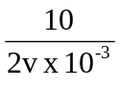
1 | (b) | (i)
  Experiment | Vol of aq KOH / cm³ | Vol of FA 2 / cm³ | Temperature rise / ºC
  1 | 25 | 50 | T₁
  2 | 50 | 25 | T₂
1 | (b) | (ii) | If T₁ = T₂ , acid is CH₃(CH₂)₃COOH  If T₁ = ½ T₂ , acid is C.  This is because dibasic acid will result in half the amount of water formed in experiment 1(or words to the same effect).
2 | (a) | (i) | NO₃⁻ + 2H⁺ + 2e → NO₂⁻ + H₂O
 |  | (ii) | Moles of S₂O₃²⁻ = 0.12 × 0.023 = 0.00276mol  2S₂O₃²⁻ + Sn⁴⁺ → Sn²⁺ + S₄O₆²⁻  Moles of Sn⁴⁺ = Moles of Sn²⁺ = 0.00276/2 = 0.00138mol  Moles of Sn²⁺ in 100 cm³ solution = 0.00138 × 100/25 = 0.00552mol  Mass of Sn = 0.00552 × 119 = 0.657g  Percentage by mass = 0.657/5.00 × 100 = 13.1%
 | (b) | (i) | Transition metals have degenerate partially filled 3d orbitals which split into two groups with a small energy gap. When electrons promote from lower to higher energy level, radiation from visible light spectrum is absorbed.  Light not absorbed is reflected and seen as the colour.  Tin compounds have fully occupied 4d orbitals, so no d-d transition can occur.
 |  | (ii) | From data booklet:  Eº(Co³⁺/Co²⁺) = + 1.82 V; Eº(I₂/I⁻) = +0.54 V ;  Eº(S₂O₈²⁻/SO₄²⁻) = + 2.01 V  2Co³⁺ +2I⁻ → 2Co²⁺ + I₂ Eº = +1.28V  2Co²⁺ + S₂O₈²⁻ → 2Co³⁺ + 2SO₄²⁻ Eº = +0.19V  Co³⁺ can exist in variable oxidation states and act as homogenous catalyst by lowering the activation energy in a reaction involving two negatively charged ions.
3 | (a) |  | 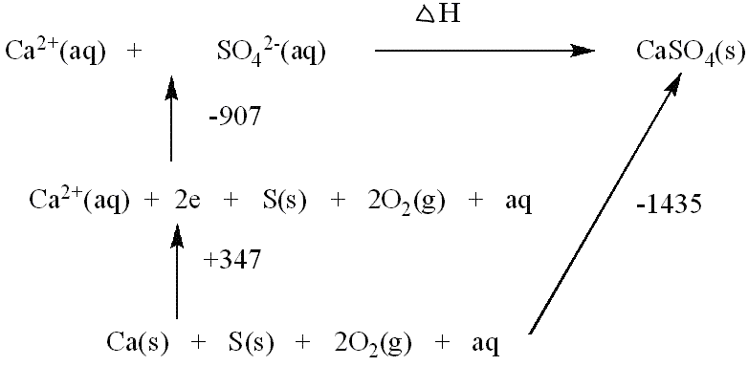  ∆H = + 907 – 347 – 1435  = – 875 kJmol⁻¹
 | (b) |  | 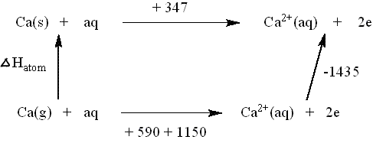  ∆H = + 347 + 1577 – 590 – 1150  = +184 kJmol⁻¹
4. | (a) |  | Large amount of energy required to break NN.
 | (b) |  | High temperature in car engines causes the equilibrium to favour endothermic reaction in order to absorb/remove excess heat. Equilibrium position for the given reaction shifts to the right, resulting in higher composition of NO in car engine.
 | (c) |  | K_{C} remains constant.  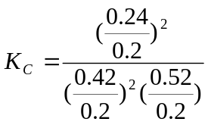  K_{c} = 0.1256 mol⁻¹ dm³  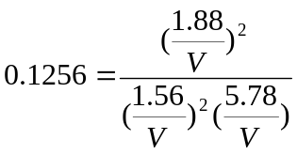  V = 0.5 dm³ ; x = 500 cm³
5 | (a) |  | Rate = k[A]  Rate = k[B][NaOH]
 | (b) | (i) | Compound A: Graph 2  Compound C: Graph 1
 |  | (ii) | Since I atom is larger, there is less effective overlap between the atomic orbitals. C – I bond is longer. Hence C – I bond is weaker and rate of hydrolysis for compound C is faster.
6 | (a) | (i) | 8Ag + 2NO₃⁻ + 10H⁺ → 8Ag⁺ + N₂O + 5H₂O  Eº_{cell} = + 0.31V
 |  | (ii) | Right to left
6 | (b)  (b) |  | Let the solubility of Ag₂Cr₂O₇ be x mol dm⁻³ before adding Na₂Cr₂O₇  Ag₂Cr₂O₇ (s)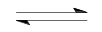2Ag⁺(aq) + Cr₂O₇²⁻(aq)  2x x  K_{sp} = [Ag⁺(aq)]² [Cr₂O₇²⁻ (aq)] = 4x³  2 x10⁻⁷ = 4x³  x = 3.68 x10⁻³ mol dm⁻³  Thus in 1 dm³ of saturated Ag₂Cr₂O₇ solution,  [Cr₂O₇²⁻] = 3.68 x10⁻³ mol dm⁻³  [Ag⁺] = 7.36 x10⁻³ mol dm⁻³  No of moles of Cr₂O₇²⁻ from Na₂Cr₂O₇ = 0.02 mol  The new conc. of Cr₂O₇²⁻ = (0.02 + 3.68 x10⁻³ ) = 0.02368 mol dm⁻³  Let no of moles of Ag₂Cr₂O₇ precipitated after adding Na₂Cr₂O₇ be y mol.  2Ag⁺ (aq) + Cr₂O₇²⁻ (aq) Ag₂Cr₂O₇ (s)  Since K_{sp} of Ag₂Cr₂O₇ = 2 x10⁻⁷ mol² dm⁻⁶  2 x 10⁻⁷ = (7.36 x10⁻³ – 2y)² (0.02368 – y)  0.02368 – y ≈ 0.02368  2 x10⁻⁷ = (7.36 x10⁻³ – 2y)² (0.02368)  y = 2.23 x 10⁻³ mol  Mass of Ag₂Cr₂O₇ precipitated = 2.23 x 10⁻³ x 432  = 0.963 g
  Conc before ppt_{n} /M | 7.36 x10⁻³ | 0.02368 | 0
  Change in conc/ M | – 2y | – y | + y
  Conc after ppt_{n} /M | 7.36 x10⁻³ – 2y | 0.02368 – y | y
 | (c) |  | AgX (s) 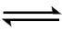 Ag⁺ (aq) + X⁻ (aq) ----- eqm 1 where X is Cl or I.  Ag⁺(aq) + 2NH₃(aq) → [Ag(NH₃)₂]⁺(aq)  The formation of [Ag(NH₃)₂]⁺ decreases [Ag⁺], causing equilibrium 1 to shift to the right.  For AgCl, ionic product decreases below its K_{sp} value and hence the white ppt dissolves.  For AgI, the K_{sp} is lower and ionic product remains above its K_{sp} value. Hence yellow ppt does not dissolve.
7 | (a) | (i) | Eº (H₂O₂/H₂O) = + 1.77 V  Snce Eº (H₂O₂/H₂O) is more positive, H₂O₂ is reduced while Vit C is oxidised.  Vitamin C act as an antioxidant by itself being oxidised.  OR  Vit C + H₂O₂ + → Vit C [oxidised] + H₂O  Eº_{cell} = + 1.38 V  Vitamin C acts as antioxidant by reducing H₂O₂.
 |  | (ii) | 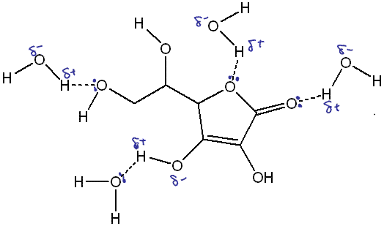
7 | (b) |  | 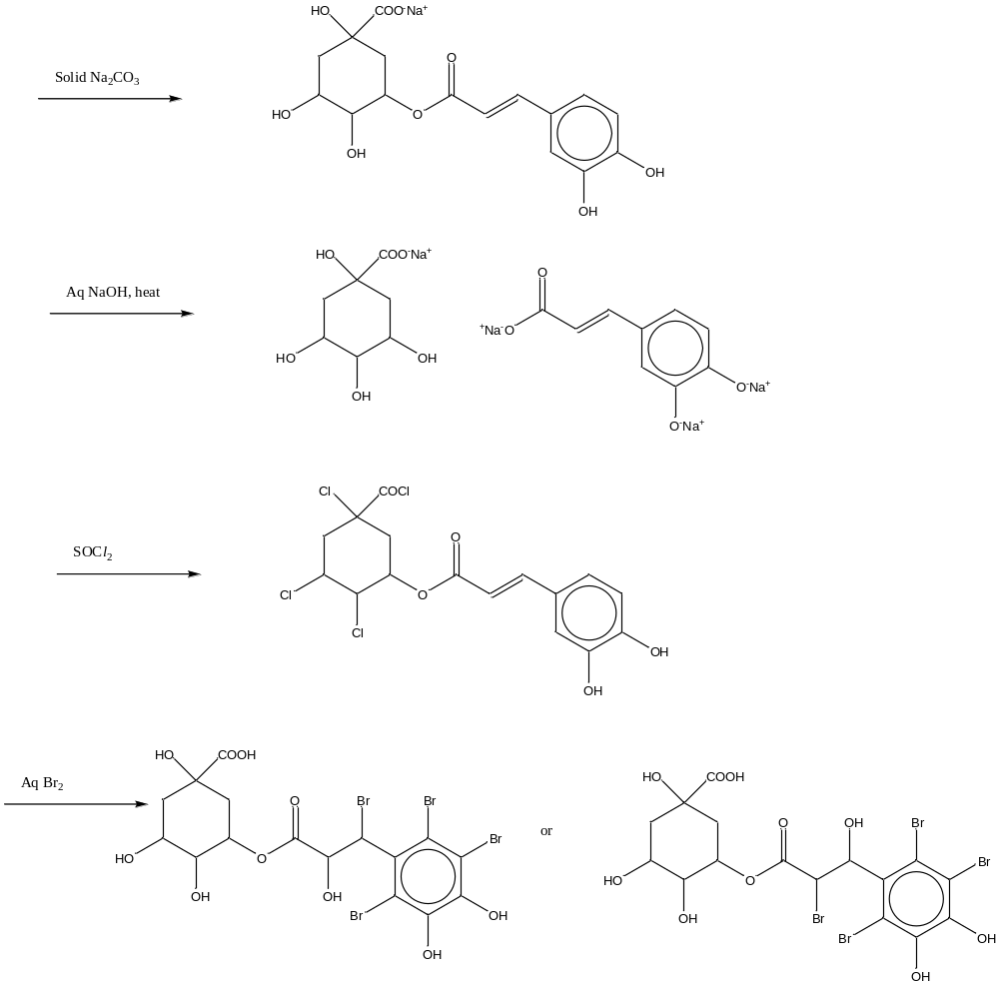
 | (c) | (i) | Neutral FeCl₃ OR aq Br₂
 |  | (ii) | Ethanoyl chloride at r.t.p.
 |  | (iii) | 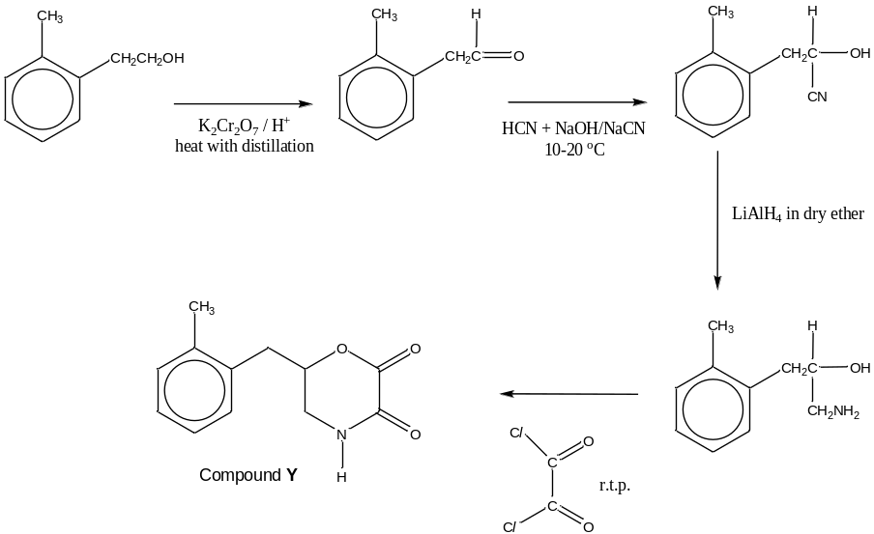
7 | (c) | (iv) | Aspirin more acidic.  Carboxylate anion is more stable than the phenoxide ion due to the  delocalisation of negative charge over 2 oxygen and 1 carbon.
 |  | (v) | 4-hydroxybenzoic acid  Intermolecular hydrogen bonding exist between molecules of 4-hydroxybenzoic acid. Close proximity of the functional groups on benzene in 2-hydroxybenzoic acid allows for intramolecular H-bonding to exist, hence resulting in less extensive intermolecular H-bonding or VDW between molecules of salicylic acid. Less energy is hence required to overcome the intermolecular forces of attraction.
8 | (a) |  | H-bond + any one of the VDW  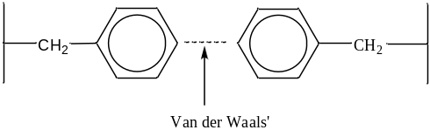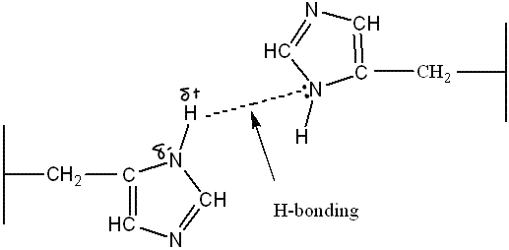  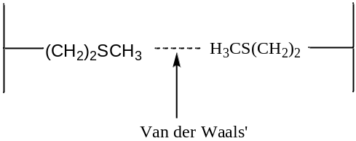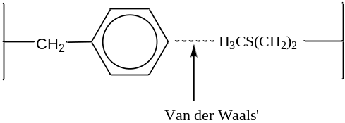
 | (b) |  | Adding acidic vinegar causes disruption of hydrogen bonds between the His side chain.  Grilling or heating causes disruption of VDW or hydrogen bonds between the side chains.  Protein is denatured and loses its native conformation.

